ACKNOWLEDGEMENT
I would like to express my sincere gratitude to all those who supported and guided me during the successful completion of my project.

First and foremost, I would like to extend my heartfelt thanks to Dr. Jaspreet Singh, my project guide and mentor at wise-techno, Anandpur Sahib, for his continuous guidance, encouragement, and valuable insights throughout the duration of my training and project. His mentorship has been instrumental in shaping the practical aspects of this work.
I am also thankful to the entire team at wise-techno for providing a professional and collaborative environment that enhanced my learning experience and helped me develop real-world skills.

I express my deep gratitude to Rayat Group of Institutions (RGI), Railmajra, for giving me the opportunity to undertake this project as part of my academic curriculum. I sincerely thank the faculty members and the staff of my college for their constant support and encouragement.

Lastly, I would like to thank my family and friends for their unwavering support, motivation, and understanding throughout this journey.

Thanking You.

Name: - HEENA
University Roll No.: - 2107074

ACKNOWLEDGEMENT
I would like to express my sincere gratitude to all those who supported and guided me during the successful completion of my project.

First and foremost, I would like to extend my heartfelt thanks to Dr. Jaspreet Singh, my project guide and mentor at wise-techno, Anandpur Sahib, for his continuous guidance, encouragement, and valuable insights throughout the duration of my training and project. His mentorship has been instrumental in shaping the practical aspects of this work.
I am also thankful to the entire team at wise-techno for providing a professional and collaborative environment that enhanced my learning experience and helped me develop real-world skills.

I express my deep gratitude to Rayat Group of Institutions (RGI), Railmajra, for giving me the opportunity to undertake this project as part of my academic curriculum. I sincerely thank the faculty members and the staff of my college for their constant support and encouragement.

Lastly, I would like to thank my family and friends for their unwavering support, motivation, and understanding throughout this journey.

Thanking You.

Name: - Arif Mohammad
University Roll No.: - 2107062

ACKNOWLEDGEMENT
I would like to express my sincere gratitude to all those who supported and guided me during the successful completion of my project.

First and foremost, I would like to extend my heartfelt thanks to Dr. Jaspreet Singh, my project guide and mentor at wise-techno, Anandpur Sahib, for his continuous guidance, encouragement, and valuable insights throughout the duration of my training and project. His mentorship has been instrumental in shaping the practical aspects of this work.
I am also thankful to the entire team at wise-techno for providing a professional and collaborative environment that enhanced my learning experience and helped me develop real-world skills.

I express my deep gratitude to Rayat Group of Institutions (RGI), Railmajra, for giving me the opportunity to undertake this project as part of my academic curriculum. I sincerely thank the faculty members and the staff of my college for their constant support and encouragement.

Lastly, I would like to thank my family and friends for their unwavering support, motivation, and understanding throughout this journey.

Thanking You.

Name: -Mansi
University Roll No.: - 2107086

ACKNOWLEDGEMENT
I would like to express my sincere gratitude to all those who supported and guided me during the successful completion of my project.

First and foremost, I would like to extend my heartfelt thanks to Dr. Jaspreet Singh, my project guide and mentor at wise-techno, Anandpur Sahib, for his continuous guidance, encouragement, and valuable insights throughout the duration of my training and project. His mentorship has been instrumental in shaping the practical aspects of this work.
I am also thankful to the entire team at wise-techno for providing a professional and collaborative environment that enhanced my learning experience and helped me develop real-world skills.

I express my deep gratitude to Rayat Group of Institutions (RGI), Railmajra, for giving me the opportunity to undertake this project as part of my academic curriculum. I sincerely thank the faculty members and the staff of my college for their constant support and encouragement.

Lastly, I would like to thank my family and friends for their unwavering support, motivation, and understanding throughout this journey.

Thanking You.

Name: - Usha Devi
University Roll No.: - 2107106

DECLARATION
I hereby certify that the work which is being presented in the B.Tech (C.S.E) project report on, " Fraud Credit Card Detection Using Machine Learning ", by Heena (2107074) in partial fulfillment of requirement for the award of degree of Bachelor of Technology in Computer Science & Engineering and submitted to the Department of Computer Science and Engineering of Rayat Group of Institutions, Railmajra, Punjab under I.K.G. Punjab Technical University, Kapurthala, is authentic record of my own work carried out during a period from January 2025 to May 2025 under the supervision of
Er. Navneet Kaur, Head of Department, CSE, Rayat Group of Institutions, Railmajra, Punjab and Dr. Jaspreet Singh, my project guide and mentor at Wise Techno, Anandpur sahib. The project presented in this report has not been submitted by me in any other University/Institute for the award of any other degree.

Signature of the Student
Heena
University Roll No.: - 2107074
This is to clarify that the above statement made by the candidate is correct to the best of my/our knowledge.
Er. Navneet Kaur
Supervisor Head of Department

The B. Tech Viva-Voice Examination of Heena has been held on___________________and accepted.


Signature of the Supervisor Signature of External Examiner

Signature of H.O.D

DECLARATION
I hereby certify that the work which is being presented in the B.Tech (C.S.E) project report on, " Fraud Credit Card Detection Using Machine Learning ", by Arif Mohammad (2107062) in partial fulfillment of requirement for the award of degree of Bachelor of Technology in Computer Science & Engineering and submitted to the Department of Computer Science and Engineering of Rayat Group of Institutions, Railmajra, Punjab under I.K.G. Punjab Technical University, Kapurthala, is authentic record of my own work carried out during a period from January 2025 to May 2025 under the supervision of
Er. Navneet Kaur, Head of Department, CSE, Rayat Group of Institutions, Railmajra, Punjab and Mr. Jaspreet Singh, my project guide and mentor at Wise Techno, Anandpur sahib. The project presented in this report has not been submitted by me in any other University/Institute for the award of any other degree.

Signature of the Student
Arif Mohammad
University Roll No.: - 2107074
This is to clarify that the above statement made by the candidate is correct to the best of my/our knowledge.
Er. Navneet Kaur
Supervisor Head of Department


The B. Tech Viva-Voice Examination of Arif Mohammad has been held on____________ and accepted.

Signature of the Supervisor Signature of External Examiner

Signature of H.O.D

DECLARATION
I hereby certify that the work which is being presented in the B.Tech (C.S.E) project report on, " Fraud Credit Card Detection Using Machine Learning ", by Mansi (2107086) in partial fulfillment of requirement for the award of degree of Bachelor of Technology in Computer Science & Engineering and submitted to the Department of Computer Science and Engineering of Rayat Group of Institutions, Railmajra, Punjab under I.K.G. Punjab Technical University, Kapurthala, is authentic record of my own work carried out during a period from January 2025 to May 2025 under the supervision of
Er. Navneet Kaur, Head of Department, CSE, Rayat Group of Institutions, Railmajra, Punjab and Mr. Jaspreet Singh, my project guide and mentor at Wise Techno, Anandpur sahib. The project presented in this report has not been submitted by me in any other University/Institute for the award of any other degree.

Signature of the Student
Mansi
University Roll No.: - 2107086
This is to clarify that the above statement made by the candidate is correct to the best of my/our knowledge.
Er. Navneet Kaur
Supervisor Head of Department
The B. Tech Viva-Voice Examination of Mansi has been held on _______________ and accepted.


Signature of the Supervisor Signature of External Examiner

Signature of H.O.D

DECLARATION
I hereby certify that the work which is being presented in the B.Tech (C.S.E) project report on, " Fraud Credit Card Detection Using Machine Learning ", by Usha Devi (2107106) in partial fulfillment of requirement for the award of degree of Bachelor of Technology in Computer Science & Engineering and submitted to the Department of Computer Science and Engineering of Rayat Group of Institutions, Railmajra, Punjab under I.K.G. Punjab Technical University, Kapurthala, is authentic record of my own work carried out during a period from January 2025 to May 2025 under the supervision of
Er. Navneet Kaur, Head of Department, CSE, Rayat Group of Institutions, Railmajra, Punjab and Mr. Jaspreet Singh, my project guide and mentor at Wise Techno, Anandpur sahib. The project presented in this report has not been submitted by me in any other University/Institute for the award of any other degree.

Signature of the Student
Usha Devi
University Roll No.: - 2107106
This is to clarify that the above statement made by the candidate is correct to the best of my/our knowledge.
Er. Navneet Kaur
Supervisor Head of Department

The B. Tech Viva-Voice Examination of Usha Devi has been held on _____________ and accepted.

Signature of the Supervisor Signature of External Examiner

Signature of H.O.D

TABLE OF CONTENT
Page no.
Acknowledgment ……………………………………………………………………………….
Declaration ………………………………………………………………………………………

Chapter 1. Introduction
1.1 general ……………………………………………………………………….
1.2 types of credit card …………………………………………………………...
1.3 role in machine learning ………………………………………………………
1.4 types of machine learning ……………………………………………………
1.5 application of machine learning …………………………………………….
Chapter 2: Dataset Description and Pre-processing
2.1 working ……………………………………………………………………….
2.2 about dataset ……………………………………………………………………
2.3 description of dataset column wise ……………………………………………
2.4 load dataset ………………………………………………………………....
2.5 find missing values and data cleaning ……………… …………………….
2.6 class balanced handling smote …………………………………………………
Chapter 3: Methodology
3.1 Workflow diagram (Flowchart)………………………………………………….
3.2 algorithms used ……………………………………………………………………
3.2.1 logistic regression ………………………………………………………....
3.2.2 decision tree ………….……………………………….…………………….
3.2.3 random forest …………………………………………………
3.2.4 support vector machine ………….………………………………….
3.2 Ensemble Learning Methods …………………………………………………
3.2.1 bagging ………….…………………………………….…………………….
3.2.2 boosting …………………………………………...…………………………
3.3 hybrid approach for fraud detection…………………….…………………….
3.4 stacking ……………………. …………………………………………………

Chapter 4: Methodology
4.1 software used ……………………………………………………………………….
4.2 evaluation metrics ………………………………………………………………
4.3 result ………. …………………...……………………………………………
Chapter 5: Discussion
5.1 benefits of hybrid approach ………………………………….………………….
5.2 comparison with algorithms……………………………………………………
5.3 challenges face ……………….……………………………………………

Chapter 6: Conclusion and Future Work
6.1 summary of findings…………………………………………………………….
6.2 about dataset ……………………………………………………………………
6.3 conclusion of the study ………...…………………………………....
6.4 references …………………………………………………………
CREDIT CARD FRAUD DETECTION USING MACHINE LEARNING

CHAPTER 1
INTRODUCTION
1.1 GENERAL
Credit card fraud is a serious problem where someone uses another person’s credit card information without permission to make purchases or withdraw money. With the rapid growth of online shopping and digital payments, the number of fraud cases has increased.
Credit card fraud means someone is using a credit card in a dishonest or illegal way. They might:
- Use a stolen card
- Steal your card number and use it online
- Pretend to be you and open a credit card account in your name
When this happens, the real cardholder (you) can lose money or get into financial trouble.

  - TYPES OF CREDIT FRAUD
1.2.1 Lost or Stolen Card Fraud
If someone finds or steals your credit card and uses it to buy things, that’s fraud. They are pretending to be you.
1.2.2 Card-Not-Present (CNP) Fraud
This happens when someone uses your card number online or over the phone, without having your physical card. For example, a thief gets your card number and uses it to shop online.
1.2.3 Phishing
This is when a scammer tricks you into giving your card details. They might send fake emails, messages, or websites that look real to fool you.
1.2.4 Skimming
A small machine is secretly added to ATMs or payment machines. It copies your card information when you use it. The thief then uses this data to make fake cards.
1.2.5 Application Fraud
A thief uses your personal details (like your name, address, and ID number) to apply for a new credit card in your name. They get the card and spend money, but you are the one responsible for the debt.

1.3 ROLE OF MACHINE LEARNING
To fight this, machine learning is being used to detect fraud more quickly and accurately. Machine learning is a type of artificial intelligence that allows computers to learn from data and make decisions. In fraud detection, it helps find unusual patterns in transactions that could mean someone is committing fraud.
Unlike traditional methods that use fixed rules, machine learning can adapt and improve over time. It can analyse thousands of transactions, learn what normal behaviour looks like, and spot suspicious activity in real time. This makes fraud detection faster, smarter, and more effective.

  - TYPES OF MACHINE LEARNING
1.4.1 Supervised Machine Learning
Supervised learning is defined as when a model gets trained on a "Labelled Dataset". Labelled datasets have both input and output parameters. In Supervised Learning algorithms learn to map points between inputs and correct outputs. It has both training and validation datasets labelled.
There are two main categories of supervised learning: -
- Classification
- Regression
1.4.2 Unsupervised Learning
Unsupervised learning is a type of machine learning technique in which an algorithm discovers patterns and relationships using unlabelled data. Unlike supervised learning, unsupervised learning doesn't involve providing the algorithm with labelled target outputs. The primary goal of Unsupervised learning is often to discover hidden patterns, similarities, or clusters within the data. Clustering is the technique mainly used in it.
1.4.3 Reinforcement Learning
Reinforcement learning is a type of machine learning that focuses on how agents can learn to make decisions through trial and error to maximize cumulative rewards. RL allow machines to learn by interacting with an environment and receiving feedback based on their actions. This feedback comes in the form of rewards or penalties.

1.5 APPLICATION OF MACHINE LEARNING
🏥 Healthcare
- Medical Diagnostics: ML assists in detecting diseases like cancer by analysing medical images (e.g., MRI, CT scans) to identify abnormalities.
🚗 Autonomous Vehicles
- Self-Driving Cars: Companies like Tesla and Waymo use ML for navigation, object detection, and decision-making in real-time driving scenarios.
🏦 Finance
- Fraud Detection: Banks utilize ML to identify unusual transaction patterns, preventing fraudulent activities.
🗣️ Natural Language Processing (NLP)
- Language Translation: Tools like Google Translate use ML to provide accurate translations by understanding context.

CHAPTER 2
DATASET DESCRIPTION
2.1 WORKING
2.1.1 Data Collection: -
First, data from past credit card transactions is collected. This includes details like the amount, time, location, type of purchase, and whether the transaction was fraud or not.
2.1.2 Data Pre-processing: -
The collected data is cleaned and prepared for the machine learning model. This may include removing missing or duplicate values, converting text into numbers, and handling imbalanced data (since fraud cases are usually much fewer than normal ones).
2.1.3 Feature Selection: -
Important features (patterns or clues) that help detect fraud are selected. For example, spending a large amount in a new location might be a sign of fraud.
2.1.4 Model Training: -
A machine learning algorithm is trained using the prepared data. The model learns the difference between normal and fraudulent transactions by analysing the patterns in the data.
2.1.5 Model Testing: -
The trained model is tested using new (unseen) transaction data to check how well it can detect fraud. Accuracy, precision, recall, and F1-score are some of the metrics used to evaluate performance.
2.1.6 Prediction: -
Once the model is trained and tested, it can be used in real-time. When a new transaction happens, the model checks it and predicts whether it is likely to be fraud or not.
2.1.7 Model Updating: -
As new fraud techniques appear; the model can be retrained with new data to improve its accuracy and stay up to date.

2.2 ABOUT DATASET: -
The dataset contains transactions made by credit cards in September 2013 by European cardholders.
This dataset presents transactions that occurred in two days, where we have 492 frauds out of 284,807 transactions. The dataset is highly unbalanced, the positive class (frauds) account for 0.172% of all transactions.
It contains only numerical input variables which are the result of a PCA transformation. Unfortunately, due to confidentiality issues, we cannot provide the original features and more background information about the data. Features V1, V2, … V28 are the principal components obtained with PCA, the only features which have not been transformed with PCA are 'Time' and 'Amount'. Feature 'Time' contains the seconds elapsed between each transaction and the first transaction in the dataset. The feature 'Amount' is the transaction Amount, this feature can be used for example-dependant cost-sensitive learning. Feature 'Class' is the response variable and it takes value 1 in case of fraud and 0 otherwise.
Given the class imbalance ratio, we recommend measuring the accuracy using the Area Under the Precision-Recall Curve (AUPRC). Confusion matrix accuracy is not meaningful for unbalanced classification.
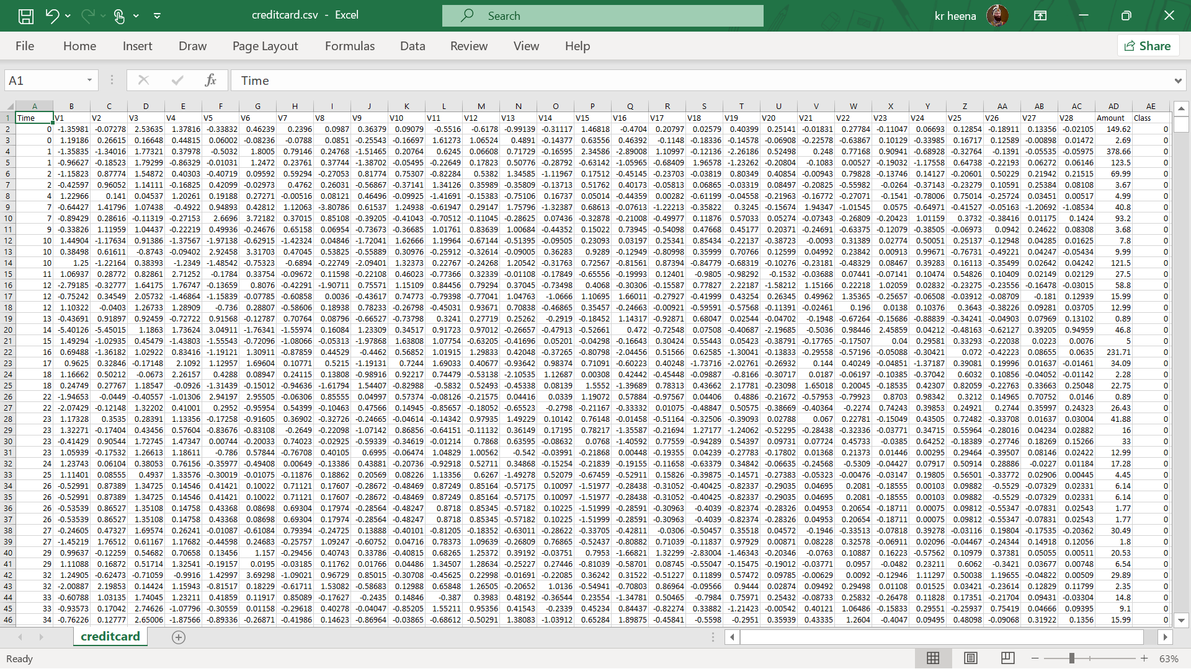
2.2 shows description of dataset.

Table 2.3:- Description of dataset columnwise
No. | Column Name | Dataset | Records | Missing Values
1 | Time | float | 284807 | No
2 | V1 | float | 284807 | No
3 | V2 | float | 284807 | No
4 | V3 | float | 284807 | No
5 | V4 | float | 284807 | No
6 | V5 | float | 284807 | No
7 | V6 | float | 284807 | No
8 | V7 | float | 284807 | No
9 | V8 | float | 284807 | No
10 | V9 | float | 284807 | No
11 | V10 | float | 284807 | No
12 | V11 | float | 284807 | No
13 | V12 | float | 284807 | No
14 | V13 | float | 284807 | No
15 | V14 | float | 284807 | No
16 | V15 | float | 284807 | No
17 | V16 | float | 284807 | No
18 | V17 | float | 284807 | No
19 | V18 | float | 284807 | No
20 | V19 | float | 284807 | No
21 | V20 | float | 284807 | No
22 | V21 | float | 284807 | No
23 | V22 | float | 284807 | No
24 | V23 | float | 284807 | No
25 | V24 | float | 284807 | No
26 | V25 | float | 284807 | No
27 | V26 | float | 284807 | No
28 | V27 | float | 284807 | No
29 | V28 | float | 284807 | No
30 | Amount | float | 284807 | No
31 | Class | int | 284807 | No

2.4 Load Dataset
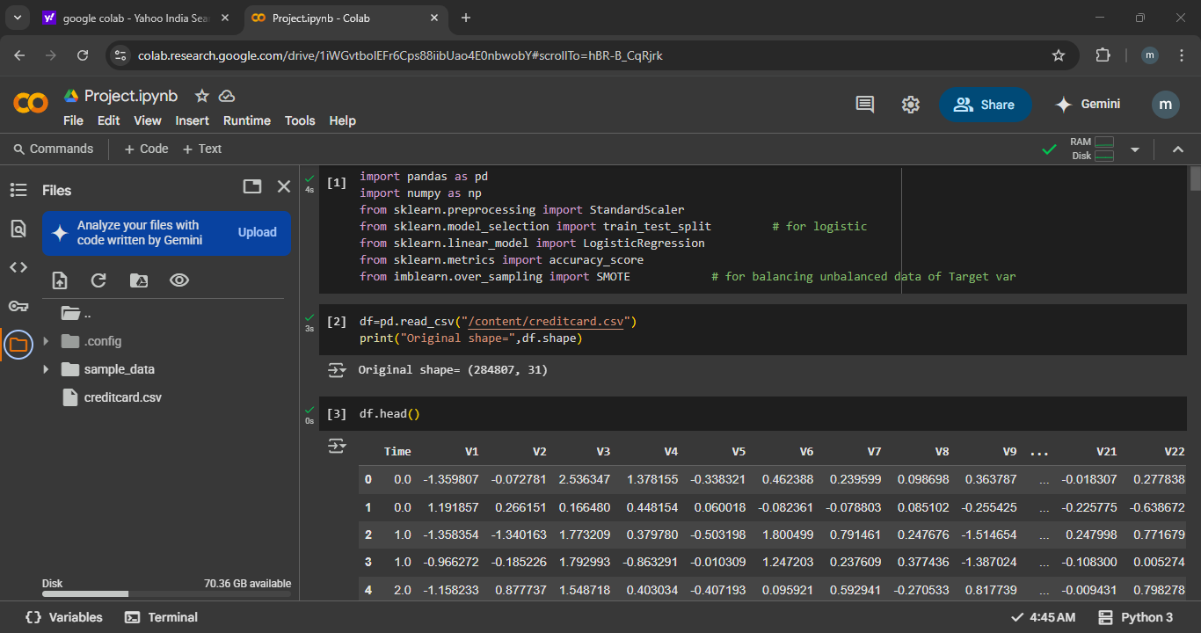
Fig 2.4 Connect dataset on GoogleColab.

2.5 Finding Missing Values and Data Cleaning
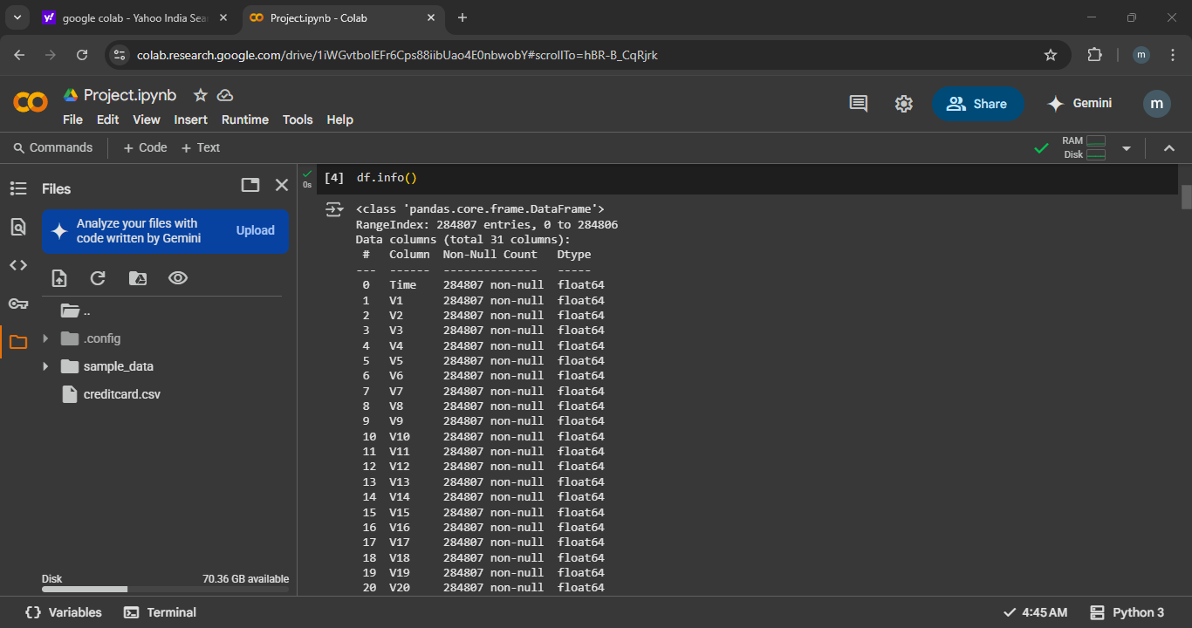
Fig 2.5 shows there is no missing values/records in our dataset.

2.5.1 Outliers:
Outliers are data points that are very different from the other values in a dataset. They lie far away from the main group of data and can affect the results of data analysis or machine learning models.
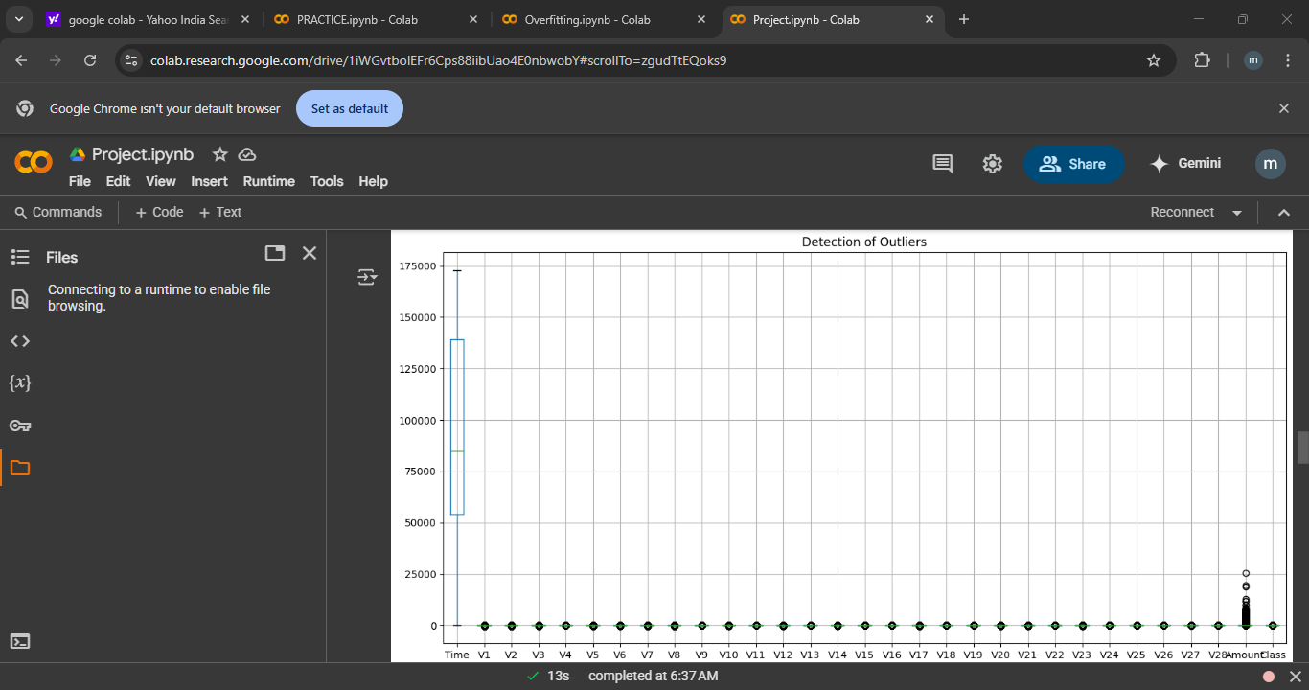
Fig 2.5.1 shows the otliers present in the dataset.
The following code is then used to handle outliers:
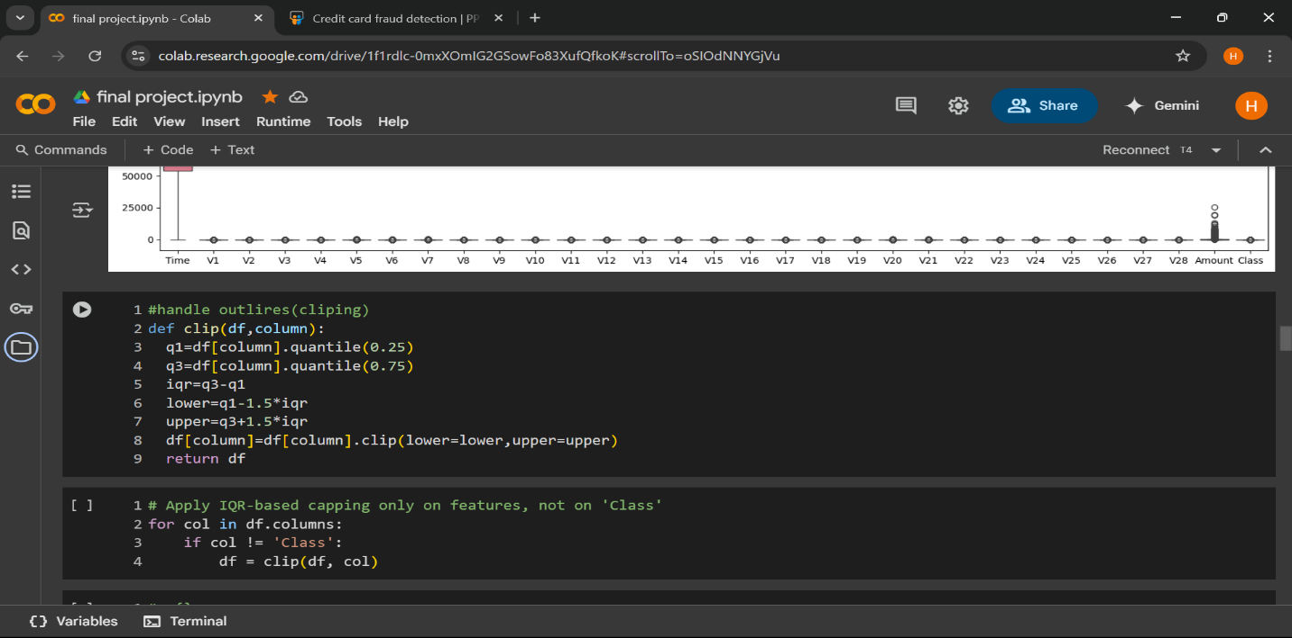

2.5.1 fig outliers handling using smote
2.5.2 Duplicates: Duplicates in a dataset are rows (data entries) that appear more than once with exactly the same values in every column. In other words, they are repeated data records.
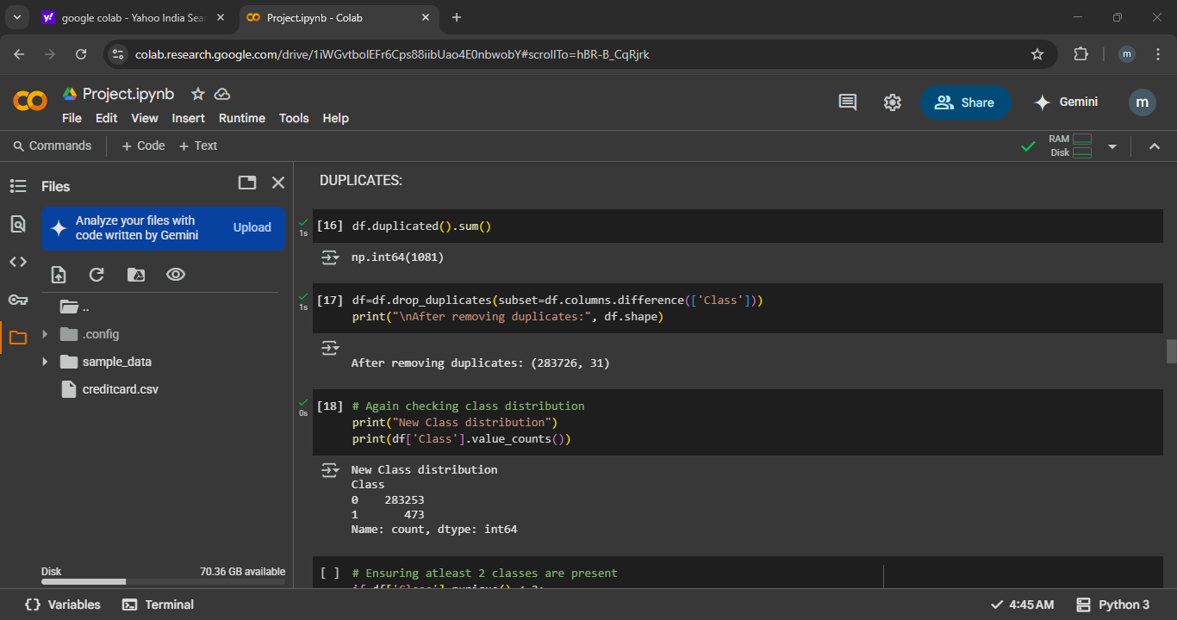
2.5.2 Fig shows the duplicated records in dataset which is then deleted to maintain it.

2.6 CLASS BALANCING HANDLING(SMOTE)
SMOTE (Synthetic Minority Over-sampling Technique) is a widely used method to address class imbalance in machine learning datasets by generating synthetic samples for the minority class. This technique enhances model performance, especially for classifiers that are sensitive to imbalanced data.

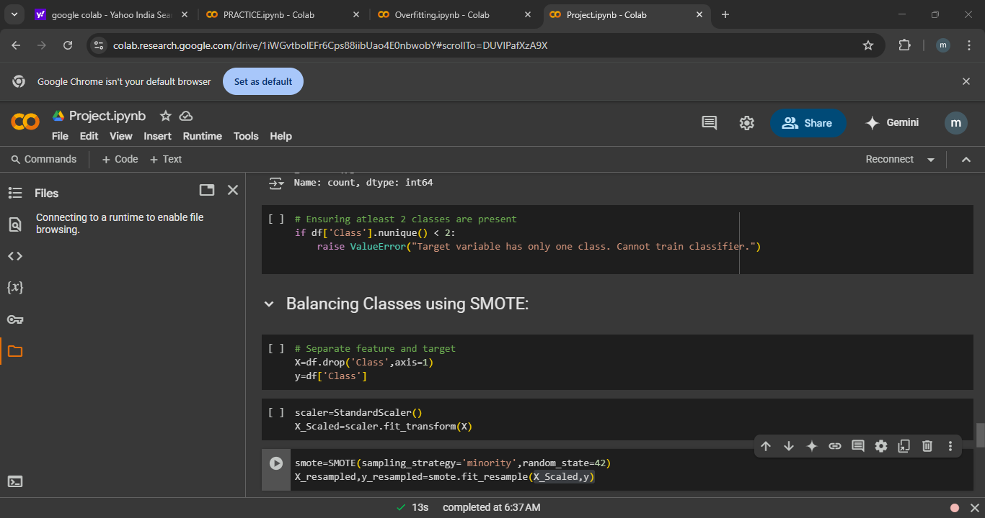
2.6 As the data is unbalanced in the Target variable which means the number of 0 are more and the number of 1 which are not even 40% of the original data, hence it is necessary to balance our data, which is balanced using SMOTE.

CHAPTER 3
METHODOLOGY
WORKFLOW DIAGRAM(FLOWCHART)
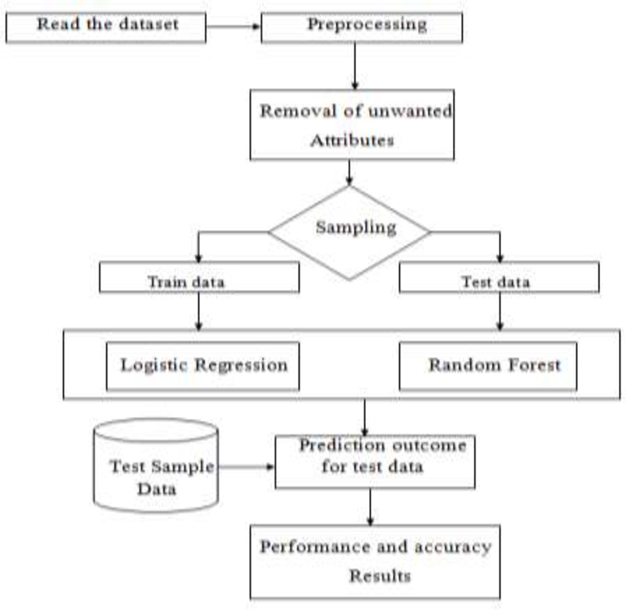

3.1 .1 Dataset Exploration and Pre-processing:
- Analyse the dataset structure, including transaction features, fraud labels, and data distribution.
- Handle missing values, outliers, and normalize data for model training.
- Address class imbalance using techniques like SMOTE or under sampling.
3.1.2 Feature Engineering and Selection:
- Extract relevant features such as transaction amount, time, location, and frequency.
- Use feature selection methods (e.g., PCA, mutual information) to reduce dimensionality.
3.1.3 Hybrid Model Development:
- Combine supervised (e.g., XGBoost) and unsupervised (e.g., Isolation Forest) techniques for improved detection.
3.1.4 Model Evaluation and Deployment:
- Validate models using k-fold cross-validation and a separate test set.
- Compare performance metrics to select the best model.

3.2 ALGORITHMS USED

- LOGISTIC REGRESSION
- DECISION TREE
- RANDOM FOREST
- SVM (Support Vector Machine)

3.2.1 LOGISTIC REGRESSION:
Logistic Regression is a fundamental machine learning algorithm used for binary classification tasks, where the goal is to predict one of two possible outcomes.
Logistic Regression estimates the probability that a given input belongs to a particular class. It applies the logistic function (also known as the sigmoid function) to map any real-valued number into a value between 0 and 1, making it ideal for classification tasks. This helps in determining the likelihood of an event happening.
For example, if the model predicts a probability of 0.8, it means there's an 80% chance of the student passing the exam.

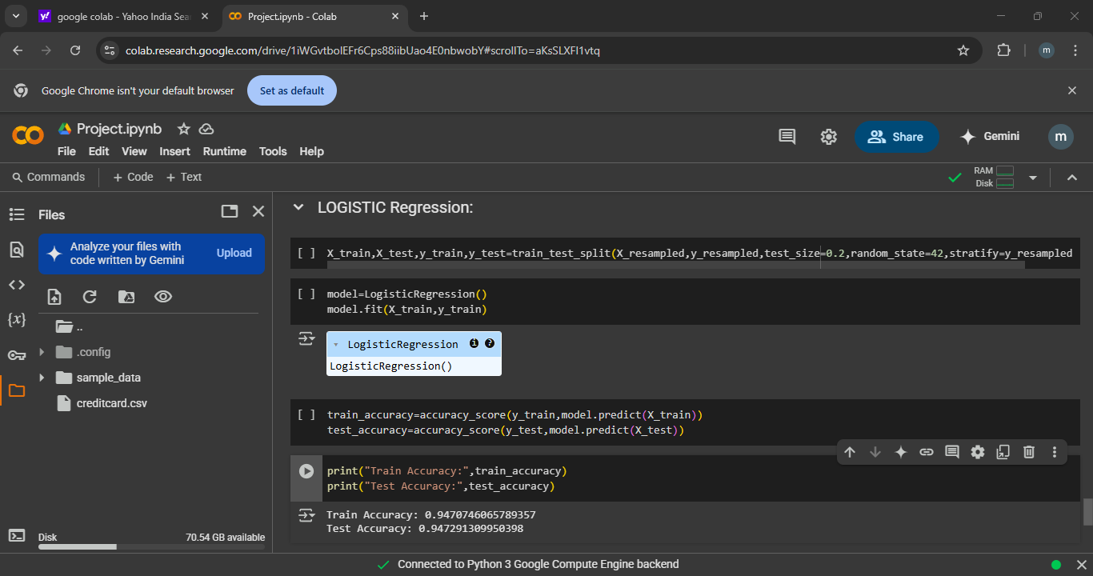
Fig 3.2.1 shows the logistic regression is being applied on the dataset which has train accuracy 0.94 and test accuracy 0.94

3.2.2 Decision Tree: -
A decision tree is a non-parametric supervised learning algorithm that recursively splits data into subsets based on feature values. It consists of: IBM
- Root Node: The starting point of the tree, representing the entire dataset.
- Decision Nodes: Intermediate nodes where the data is split based on feature values.
- Leaf Nodes: Terminal nodes that represent the output or prediction.
The tree is constructed by selecting the best feature to split the data at each node, aiming to increase homogeneity within the subsets.

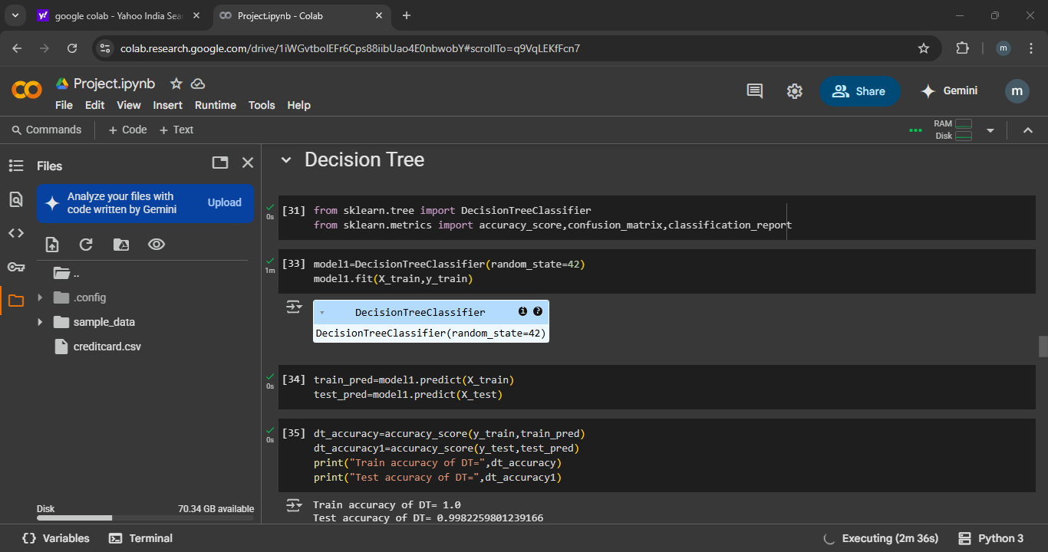
Fig 3.2.2 shows the that the Decision Tree has been applied on our dataset, where train accuracy is 1.0 (100%) and test accuracy is 0.99(99%).

3.2.3 RANDOM FOREST: -
Random Forest is a robust ensemble learning algorithm that combines multiple decision trees to improve predictive accuracy and control overfitting. It's widely used for both classification and regression tasks due to its simplicity and effectiveness.
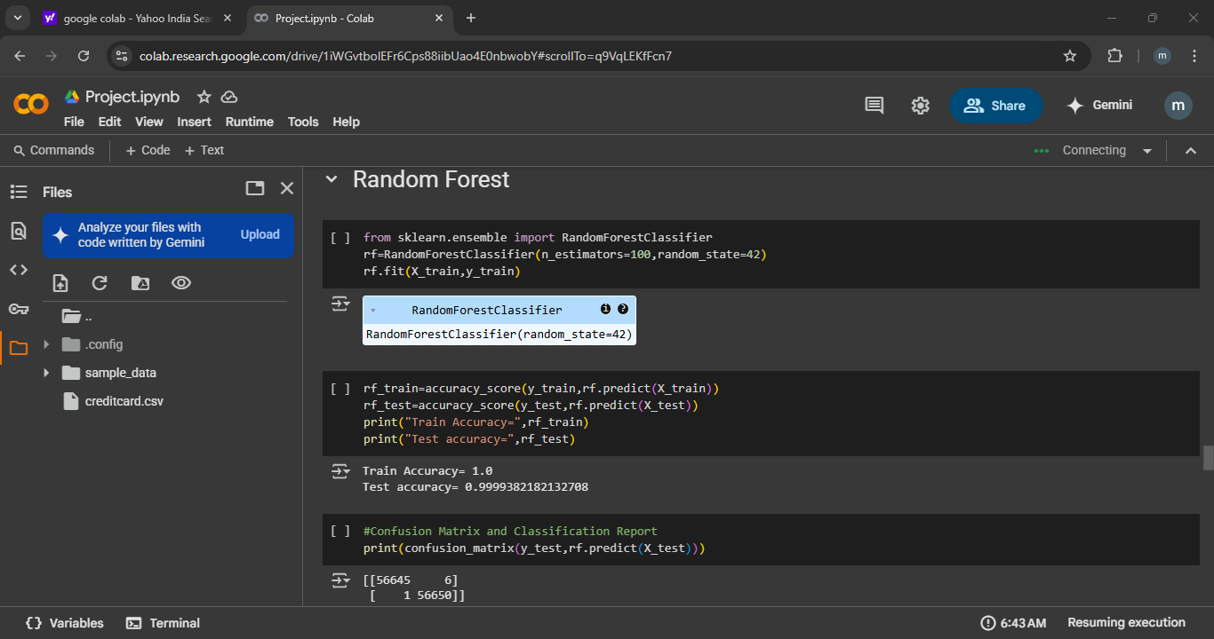
3.2.4 SVM (SUPPORT VECTOR MACHINE)
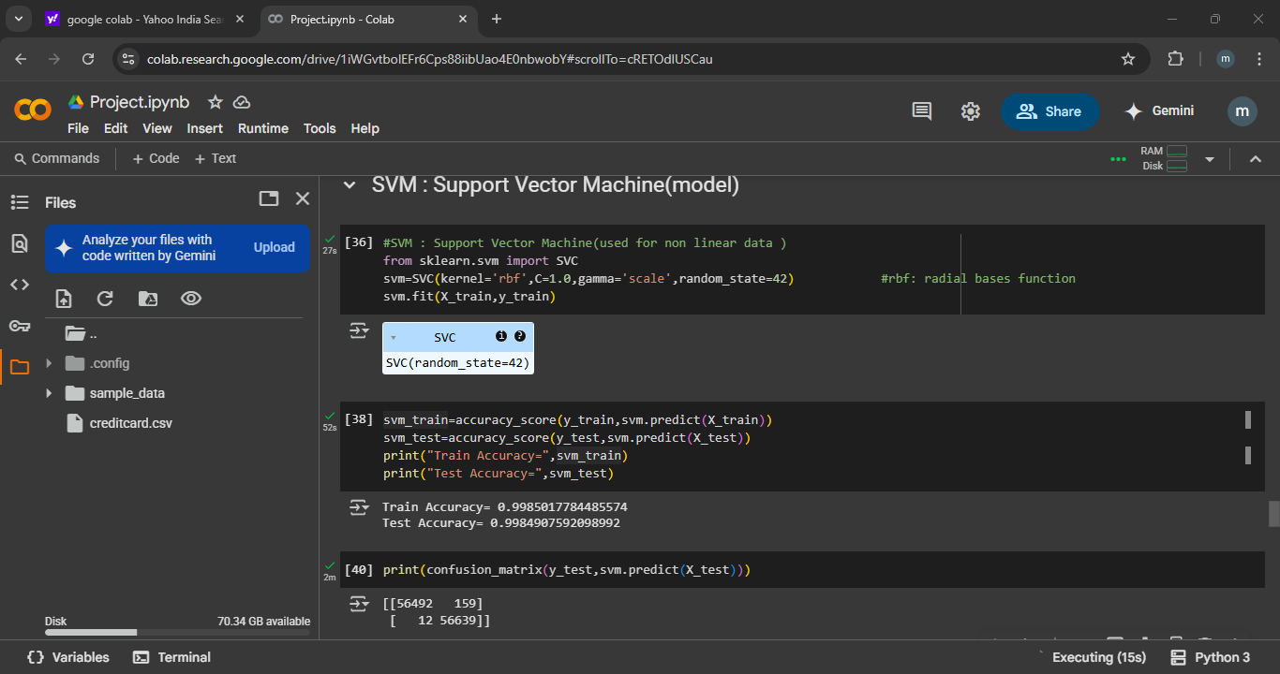
Support Vector Machines (SVMs) are powerful supervised learning algorithms widely used for classification and regression tasks. They are particularly effective in high-dimensional spaces and for cases where the number of dimensions exceeds the number of samples. SVMs are also versatile in handling both linear and non-linear data through the use of kernel functions.

Fig3.2.4 SVM Model. Train Accuracy=0.9985, Test accuracy=0.9984.

3.3 ENSEMBLE LEARNING MODELS
Ensemble learning is a machine learning paradigm where multiple models (often called base learners) are combined to produce a stronger overall model

3.3.1 BAGGING (Bootstrap Aggregating)
- Concept: Trains multiple models in parallel on different subsets of the training data, each sampled with replacement.
- Goal: Reduce variance and prevent overfitting.
- Example: Random Forest, which builds multiple decision trees using random subsets of features and data samples.
3.3.2 BOOSTING
. Concept: Trains models sequentially, each new model correcting errors made by the previous ones.
. Goal: Reduce bias and improve predictive accuracy.
3.3.3 STACKING (Stacked Generalization)
- Concept: Trains multiple models (base learners) and then uses another model (meta-learner) to combine their predictions.
- Goal: Leverage the strengths of different models to improve accuracy.
- Example: Using logistic regression as a meta-learner to combine predictions from decision trees, support vector machines, and neural networks.

3.3.4 HYBRID APPROACH FOR FRAUD DETECTION
A hybrid approach to fraud detection combines multiple machine learning (ML) and deep learning (DL) techniques to enhance the accuracy, adaptability, and robustness of fraud detection systems. By integrating various models, these approaches can effectively identify complex and evolving fraudulent patterns across different domains, such as financial transactions, online payments, and invoicing platforms.
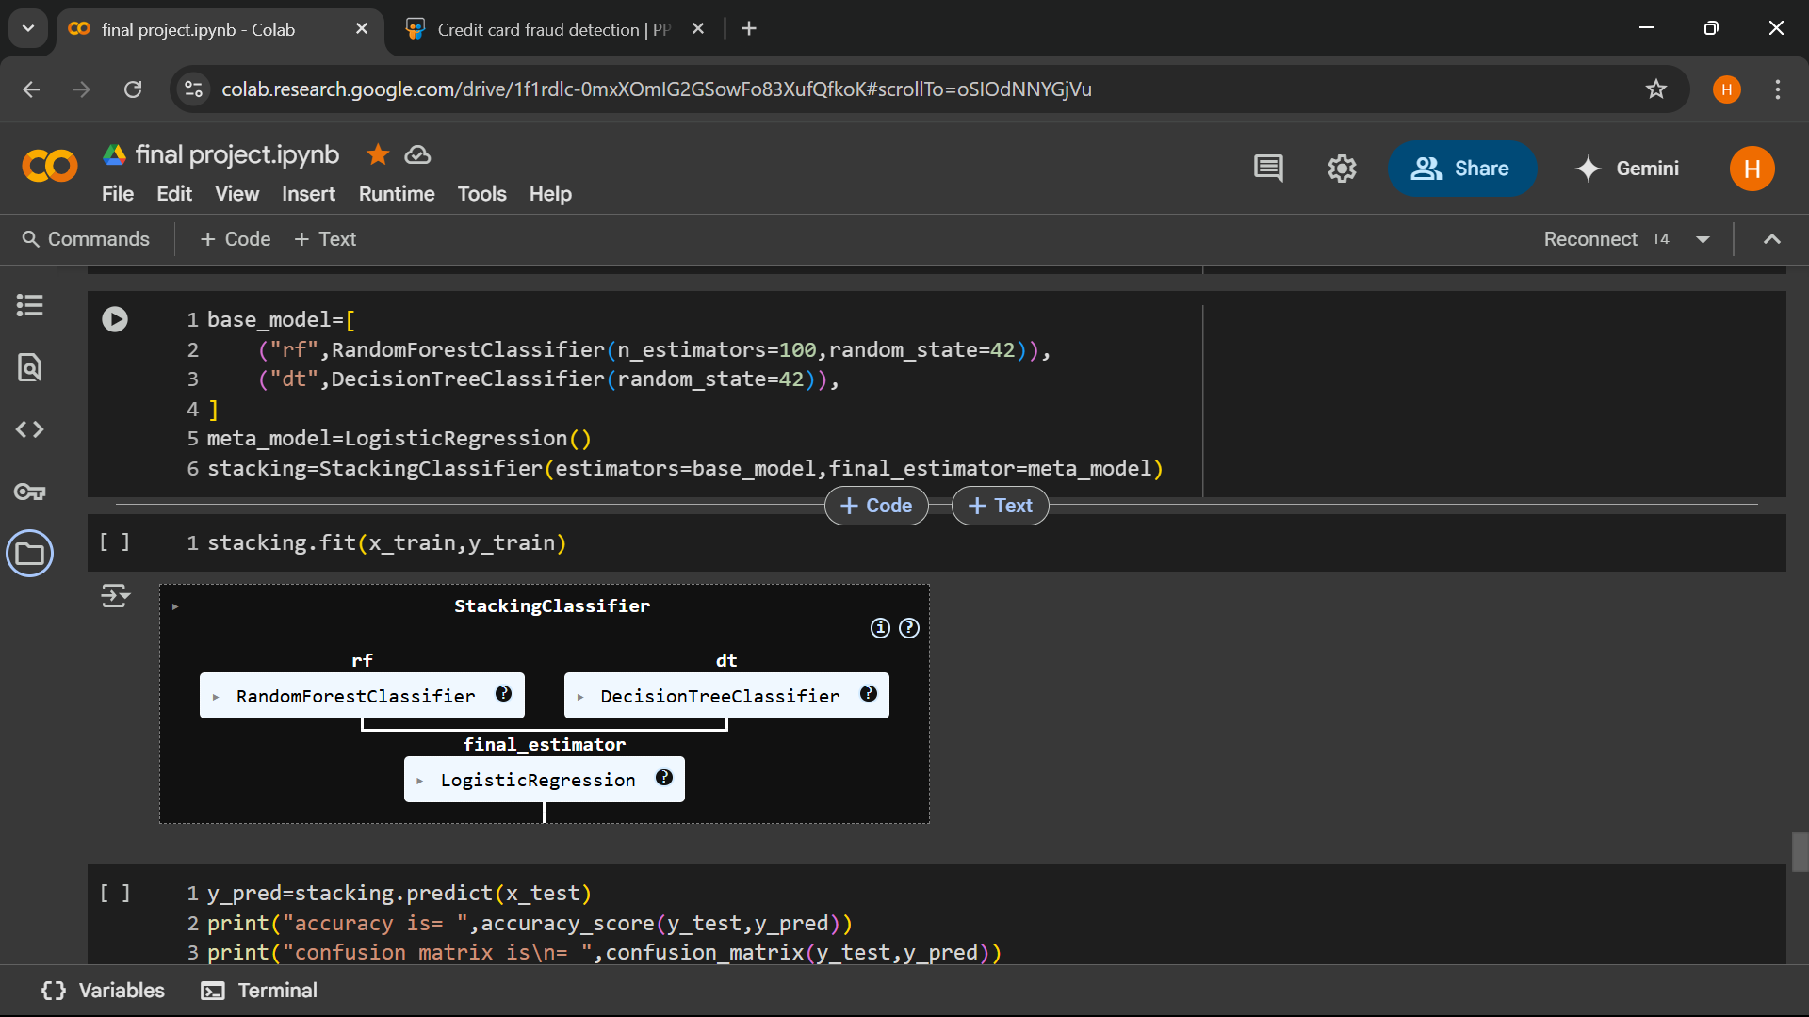
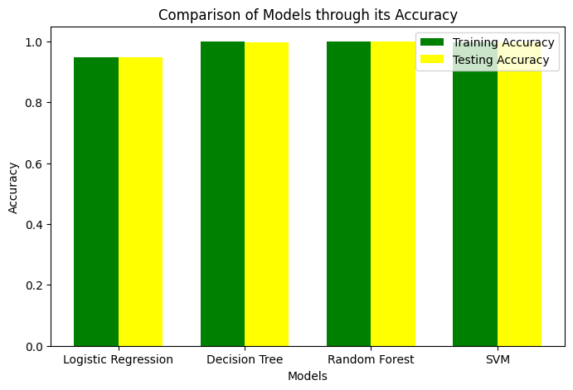

Fig 3.3.5 shows comparison of all four models used in terms of accuracy.

CHAPTER 4
MODEL IMPLEMENTATIONS AND SOFTWARE USED
4.1 SOFTWARE USED
Operating System: WINDOWS 11
IDE Tool: Google Collab
Coding Languages: Python
APIs: Pandas, NumPy, Matplotlib
Dataset: Kaggle

4.2 EVALUATION METRICS

Report | 0,1 | Accuracy | Precision | Recall | F1 score
Decision Tree | 0  1 | 1.00  1.00 | 1.00  1.00 | 1.00  1.00 | 1.00  1.00
Random Forest | 0  1 | 1.00  1.00 | 1.00  1.00 | 1.00  1.00 | 1.00  1.00
SVM | 0  1 | 1.00  1.001 | 1.00  1.00 | 1.00  1.00 | 1.00  1.00
HYBRID APPROACH | 0  1 | 1.00  1.00 | 1.00  1.00 | 1.00  1.00 | 1.00  1.00
4.1 table evaluation metrics

4.3 PRE-PROCESSING: -
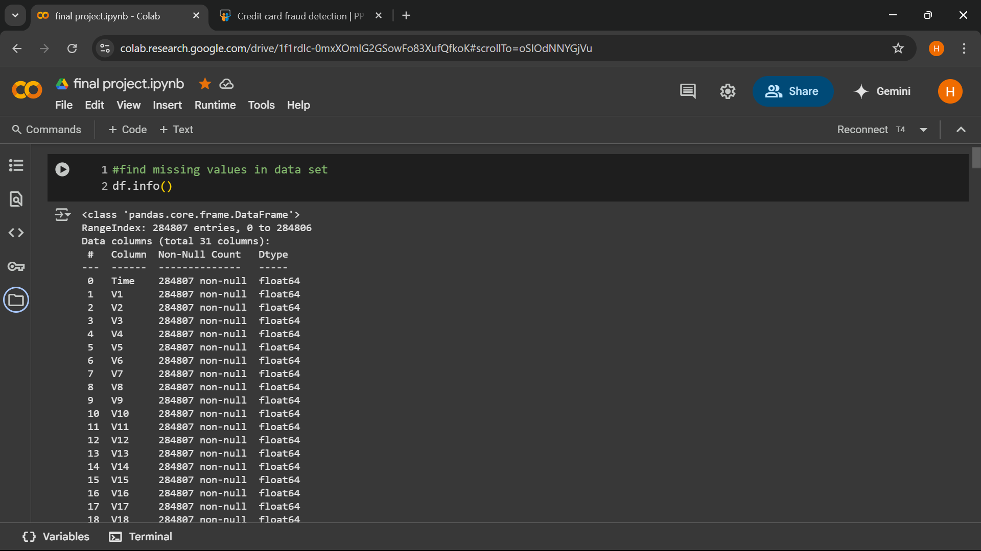
4.1 fig Importing python packages for data exploration, pre-processing and for using random
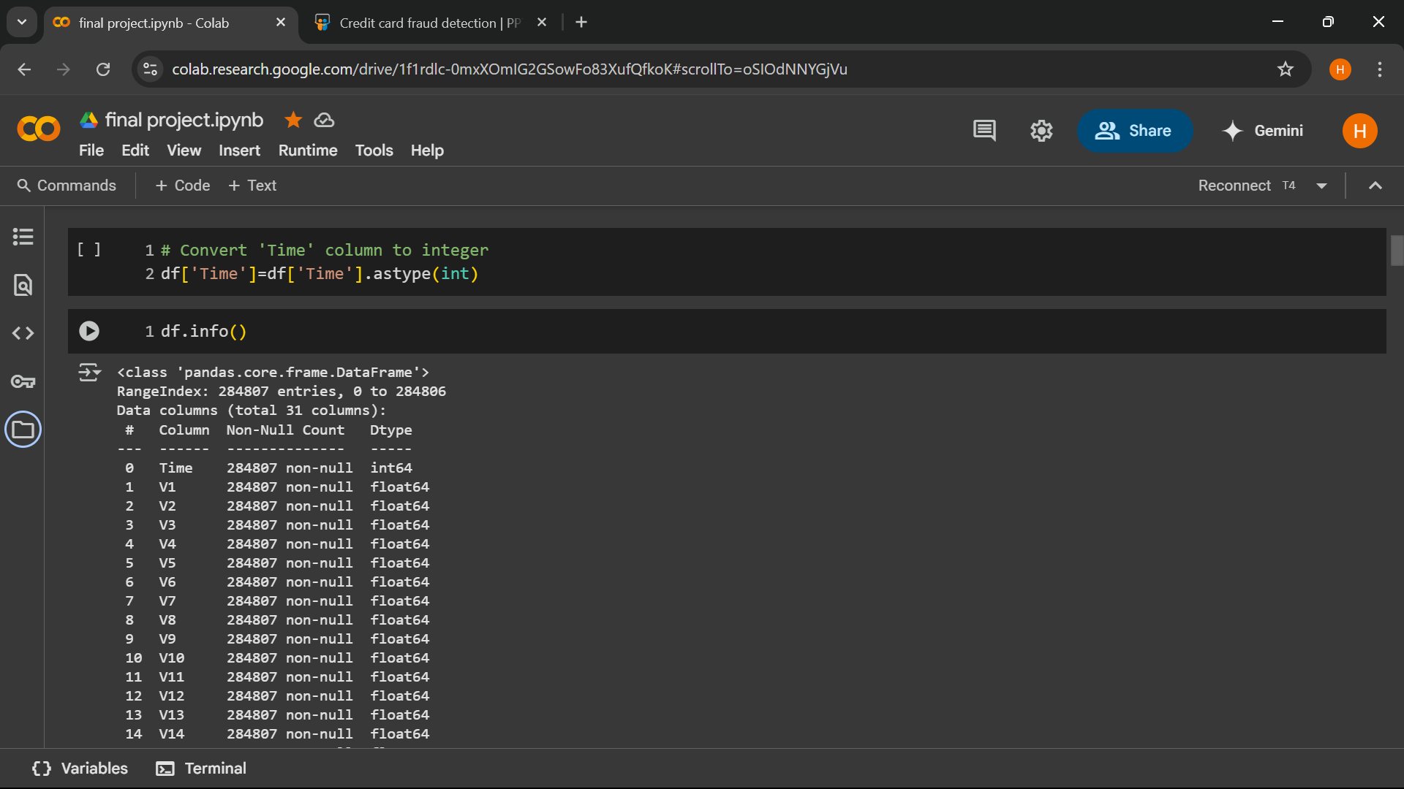
4.2 pre-processing change time type int
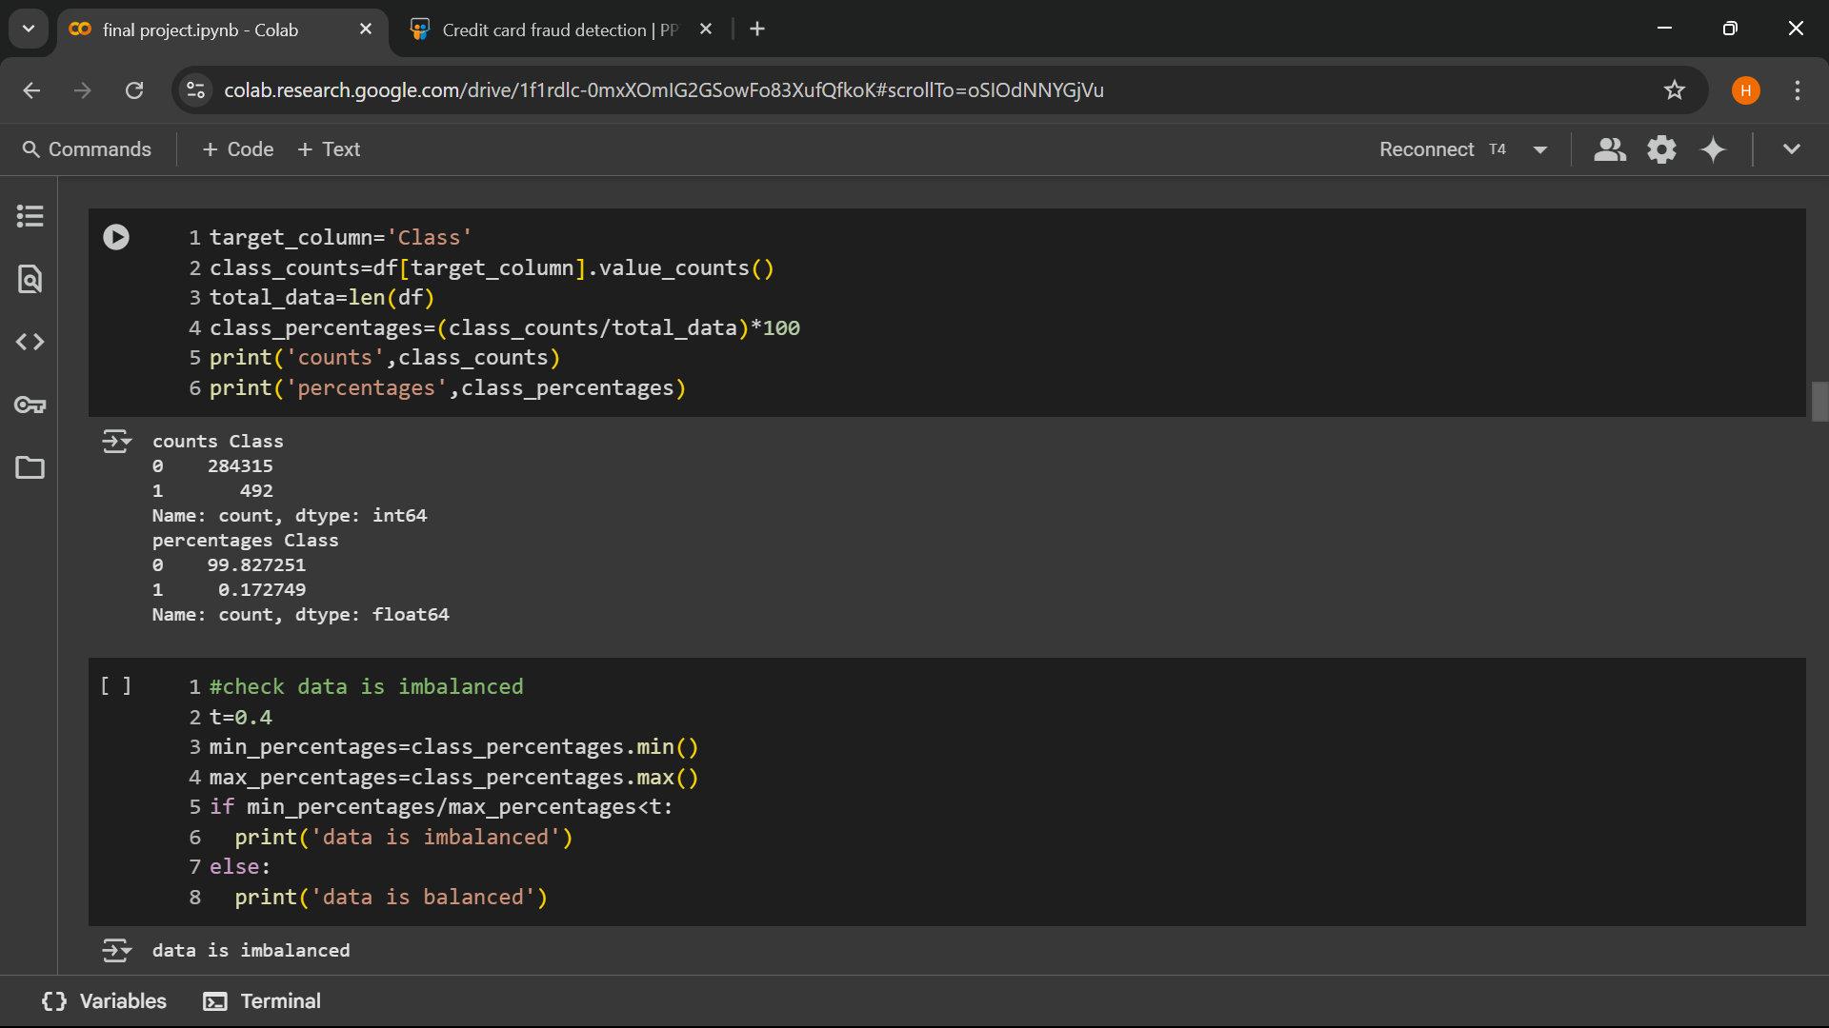
4.3 fig Data is imbalanced
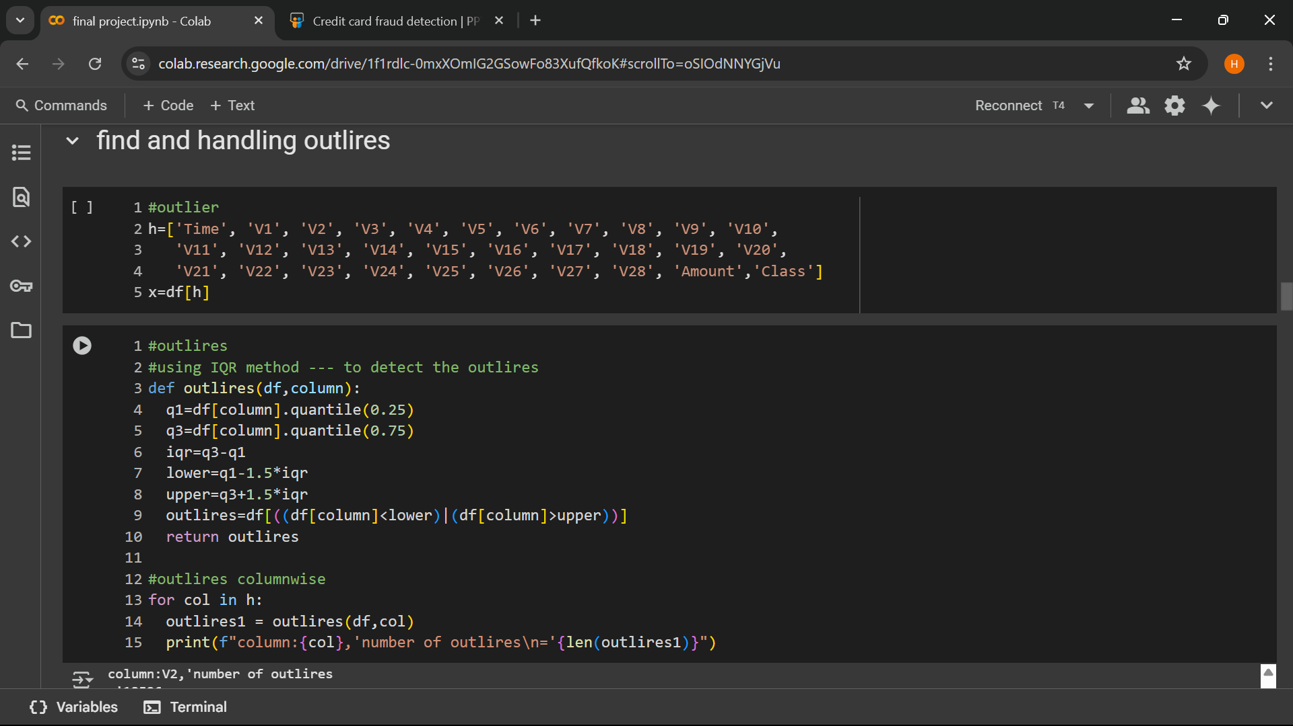
4.4 fig Find outliers

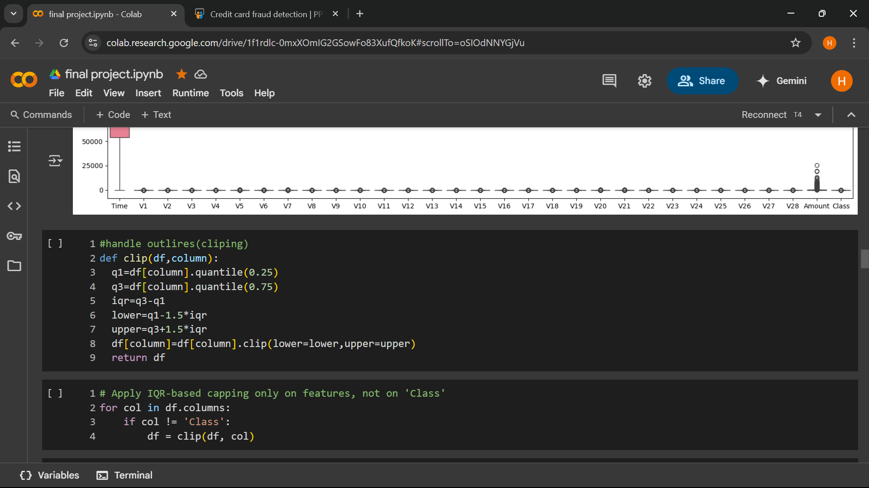
4.5 Handling outliers
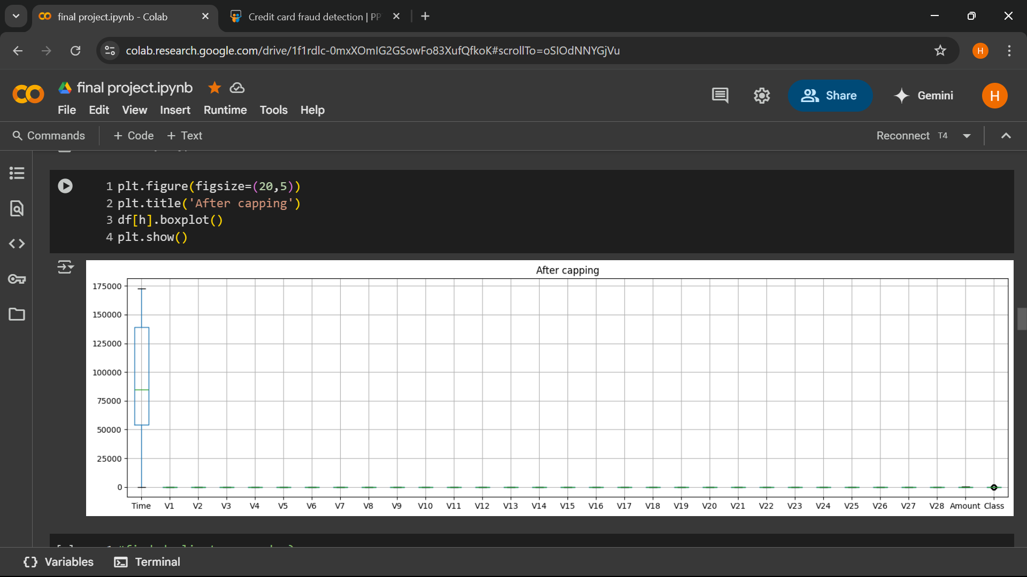
4.6 Outliers graph

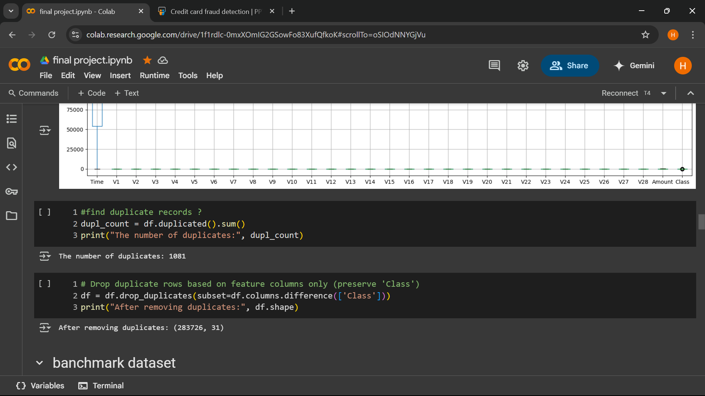
4.7 fig Find and remove duplicates records
4.4 Data Pre-processing: -
Pre-processing is the process of three important and common steps as follows: • Formatting: It is the process of putting the data in a legitimate way that it would be suitable to work with. Format of the data files should be formatted according to the need. Most recommended format is .csv files. • Cleaning: Data cleaning is a very important procedure in the path of data science as it constitutes the major part of the work. It includes removing missing data and complexity with naming category and so on. For most of the data scientists, Data Cleaning continues of 80% of work. • Sampling: This is the technique of analysing the subsets from whole large datasets, which could provide a better result and help in understanding the behaviour and pattern of data in an integrated way
4.4 Data Exploration: -

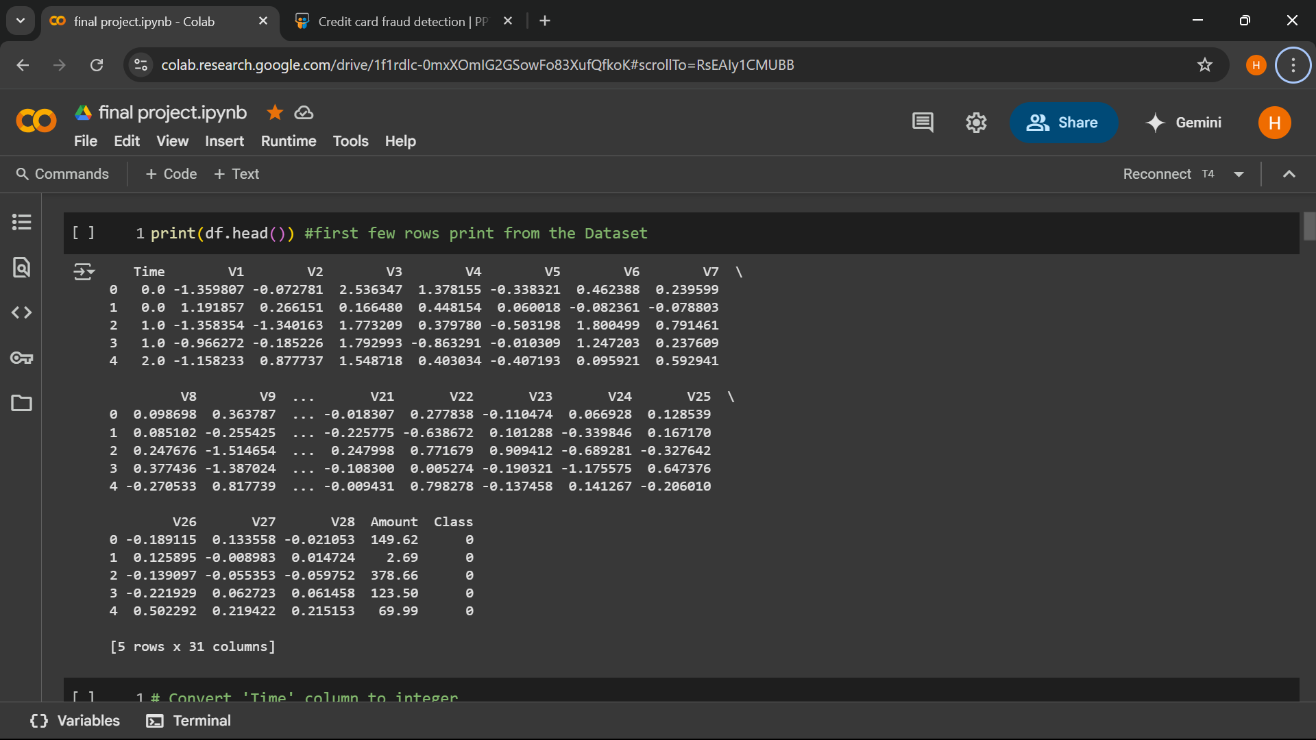
4.8 Pre-processing
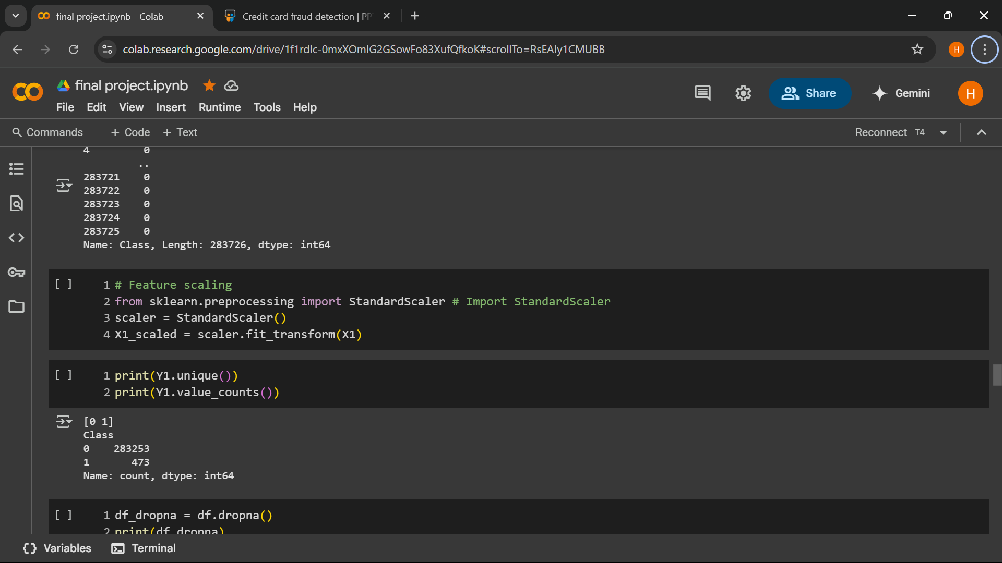
4.4.1 Pre-processing with python commands
4.9 Pre-processing

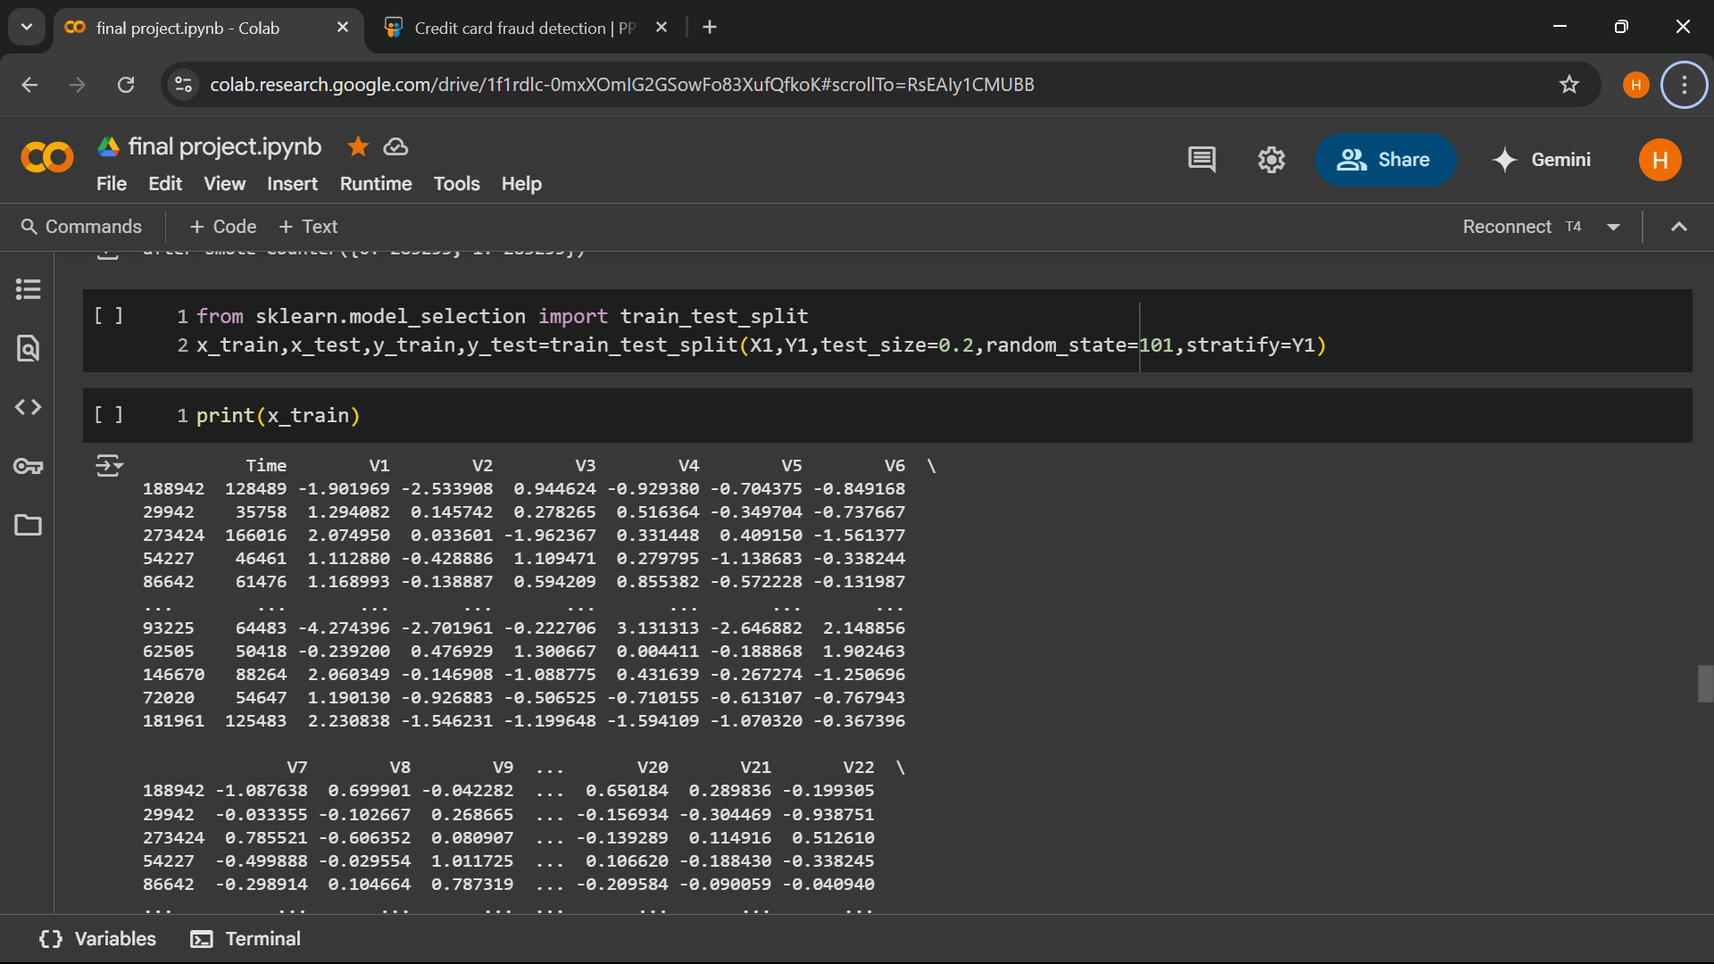
4.10 Training and testing data

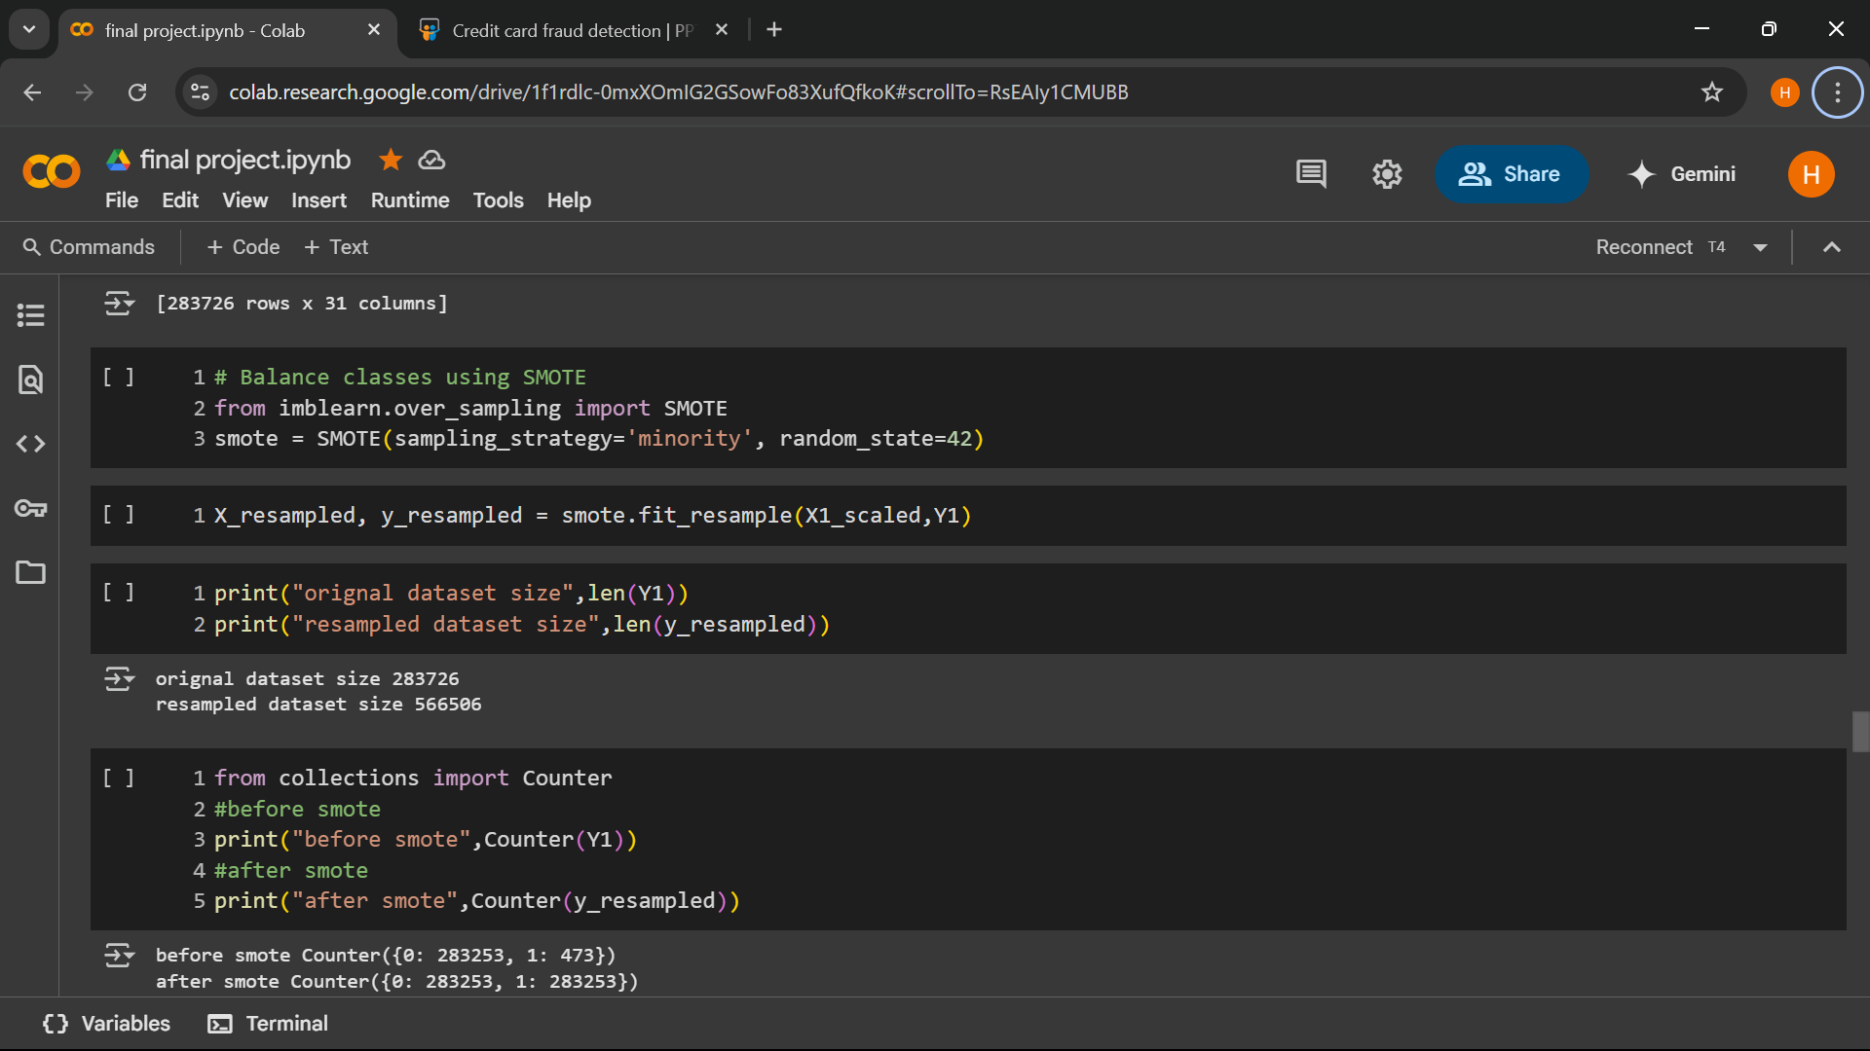
4.11 Pre-processing using smote

CHAPTER -5
DISCUSSION
5.1 Benefits of hybrid Approach:

5.1.1 Increased Productivity:
By giving workers the option to choose between working from home or in an office, hybrid work models help to boost productivity. Employees working in hybrid environments frequently encounter fewer distractions at home, which helps them concentrate and complete tasks more quickly (Choudhury, Foroughi, & Larson, 2020). Employees who have flexibility in managing their work schedules are also able to make the most of their productive times, which results in higher productivity. Employees using hybrid models can also customize their workspace to their preferences, which can improve focus and task performance even more. Ultimately, this flexible approach outperforms strict office-based work arrangements in terms of productivity.
5.1.2. Improved Work-Life Balance:
Employees can better balance their personal and professional lives with the flexibility that a hybrid work model provides. According to research by Allen et al. (2015), workers who have more control over their work schedule and location report feeling less stressed and having a better balance between their personal and professional obligations. This model lessens burnout by enabling workers to take part in personal activities or spend more time with their families. Employees can take care of personal matters without sacrificing the quality of their work when they can modify their work hours and spend less time commuting. Consequently, the hybrid model greatly enhances job satisfaction and employee well-being.
5.1.3. Cost Savings for Employers and Employees:
The cost savings provided by hybrid work models are advantageous to both employers and employees. Lower utility costs and less office space are major benefits for businesses. By eliminating the need for a physical office space, businesses can save money on rent, electricity, and office supplies (Global Workplace Analytics, 2021). Conversely, workers save money on lunches, parking, gas, and commuting, which increases their disposable income. Thus, the hybrid model is a cost-effective solution for contemporary workplaces since it allows both parties to lower overhead costs. These financial savings are especially helpful for businesses looking to minimize their operating costs or during uncertain economic times.

5.2 Comparison with Algorithms
- SVM is based on geometrical properties of the data while logistic regression is based on statistical approaches.
- The risk of overfitting is less in SVM, while Logistic regression is vulnerable to overfitting.

A decision tree is a hierarchical model that supports decisions and their consequences, including chance event outcomes, resource costs, and utility, and is used to display conditional control statements.

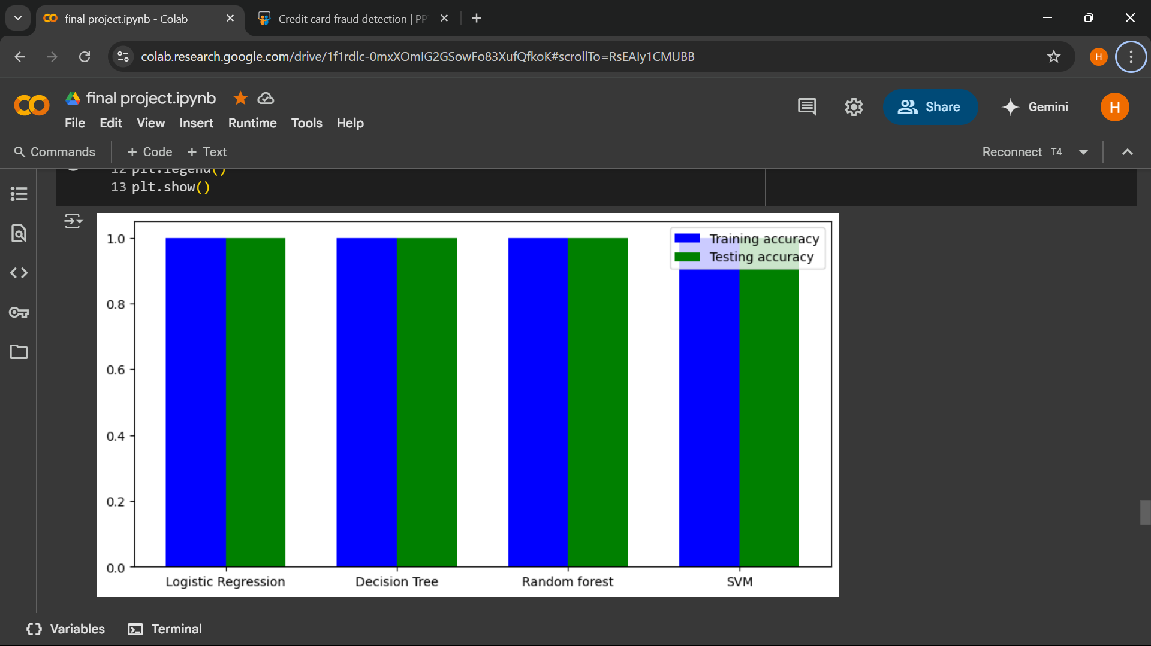
Fig 5.2 Comparisn of models through its training and testing accuracy.

5.3 Challenges Faces:
Credit card fraud detection using machine learning comes with several challenges that need to be addressed for effective fraud prevention:
Imbalanced Datasets – Fraudulent transactions are rare compared to legitimate ones, making it difficult for ML models to learn effectively.
    - False Positives & False Negatives – Incorrectly flagging legitimate transactions as fraud can frustrate customers, while missing actual fraud can lead to financial losses.
    - Evolving Fraud Tactics – Fraudsters constantly adapt their methods, requiring ML models to be continuously updated.
    - Data Privacy & Security – Using sensitive financial data for training ML models raises ethical and regulatory concerns.
    - Algorithm Transparency – Some ML models, especially deep learning-based ones, operate as "black boxes," making it hard to interpret their decisions.
    - Real-Time Processing – Fraud detection needs to happen instantly, which demands high computational power and efficient algorithms.
5.4 ROC CURVE: - AUC-ROC curve is a graph used to check how well a binary classification model works. It helps us to understand how well the model separates the positive cases like people with a disease from the negative cases like people without the disease at different threshold level. It shows how good the model is at telling the difference between the two classes by plotting:
- True Positive Rate (TPR): how often the model correctly predicts the positive cases also known as Sensitivity or Recall.
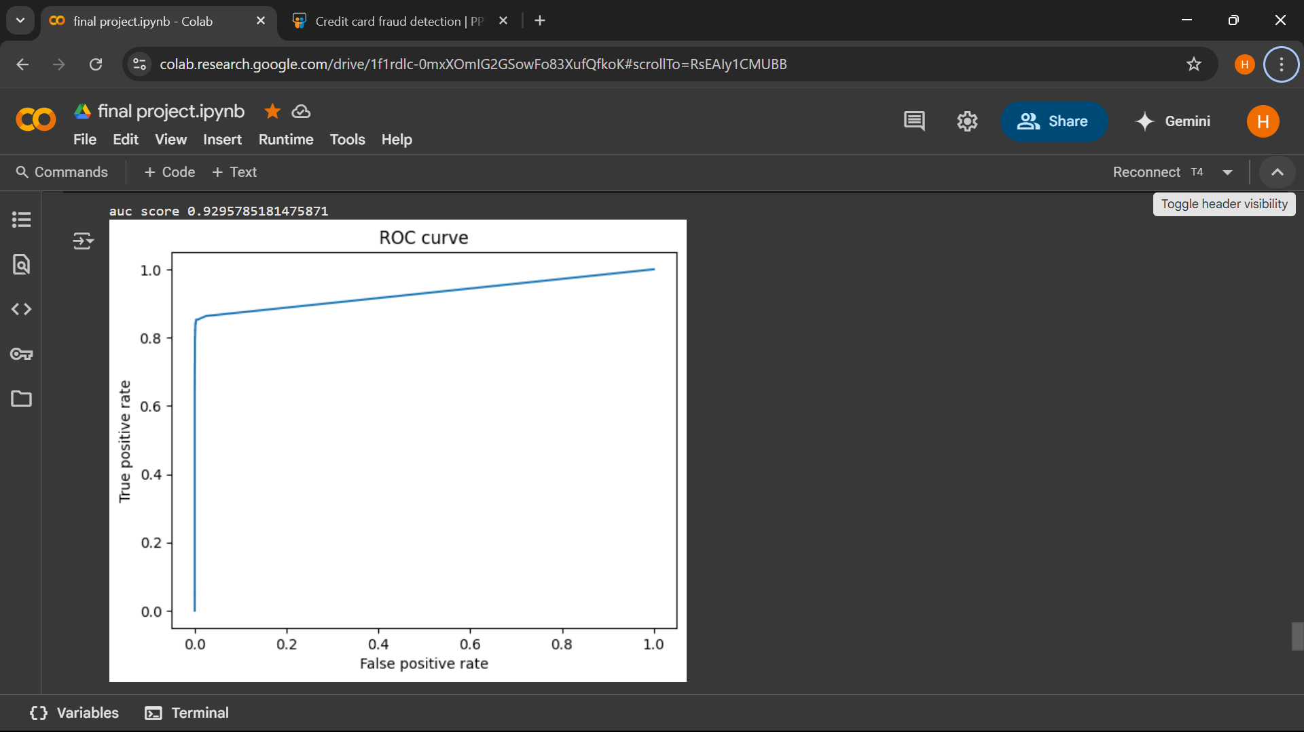
- False Positive Rate (FPR): how often the model incorrectly predicts a negative case as positive.
5.4 ROC – AUC Curve

CHAPETR 6
CONCLUSION AND FUTURE WORK
6.1 SUMMARY OF FINDINGS
Total number of cases are---- 284807
Number of Non fraud cases----284304
Number of fraud cases----492
Percentage of fraud cases ---0.17%
NON-FRAUD CASE AMOUNT STATS: -
Count 284315.000000
Mean 88.29122
Std 250.105092
Min 0.000000
25% 5.650000
50% 22.000000
75% 77.050000
Max----25691.160000
Name: Amount, dtype: float64

FRAUD CASE AMOUNT STATS: -
Count 492.000000
Mean 122.211321
Std 256.683288
Min 0.000000
25% 1.000000
50% 9.250000
75% 105.890000
Max 2125.870000
Name: Amount, Dtype: float64

6.2 CONCLUSION OF THE STUDY
Credit card fraud detection is crucial for financial security, and machine learning has significantly improved its accuracy. By analyzing transaction patterns, ML models can identify fraudulent activities and reduce financial losses. However, challenges such as imbalanced datasets, false positives, and evolving fraud tactics require continuous Credit card fraud detection is a crucial aspect of financial security, helping banks and businesses identify fraudulent transactions and prevent financial losses. Machine learning plays a significant role in modern fraud detection systems by analysing transaction patterns and detecting anomalies.
Machine learning is used in credit card fraud detection because it enhances accuracy, efficiency, and adaptability in identifying fraudulent transactions. Here’s why ML is a game-changer in fraud detection:
- Pattern Recognition – ML models analyse vast amounts of transaction data to detect unusual spending behaviours that may indicate fraud.
- Real-Time Detection – ML enables instant fraud detection, allowing financial institutions to block suspicious transactions before they cause harm.
- Handling Large Data Volumes – Traditional fraud detection methods struggle with massive transaction datasets, but ML can process and analyse them efficiently.
- Adaptive Learning – Fraud tactics evolve constantly, and ML models can update themselves to recognize new fraud patterns.
- Reducing False Positives – ML improves fraud detection accuracy, minimizing cases where legitimate transactions are mistakenly flagged as fraudulent.

6.3 REFERENCES
[1] Chen, Y., et al. (2024). "A Hybrid Deep Learning Model for Real-Time Credit Card Fraud Detection with Edge Computing." IEEE Transactions on Artificial Intelligence, vol. 5, no. 2, pp. 112-125.
[2] Gupta, R., & Patel, S. (2023). "Explainable AI for Fraud Detection: A Comparative Study of SHAP and LIME in Financial Transactions." Journal of Financial Data Science, vol. 8, no. 3, pp. 45-60.
[3] Wang, L., et al. (2023). "Federated Learning for Privacy-Preserving Fraud Detection in Banking Systems." ACM Computing Surveys, vol. 56, no. 1, pp. 1-32.
[4] Almeida, F., & Santos, J. (2022). "Ensemble Learning with GANs for Handling Imbalanced Credit Card Fraud Datasets." Expert Systems with Applications, vol. 205, p. 117234.
[5] Zhang, H., et al. (2022). "Graph Neural Networks for Fraud Detection in Transaction Networks." Neural Networks, vol. 158, pp. 344-355.
[6] Kumar, P., et al. (2021). "A Comparative Analysis of Autoencoders and Isolation Forest for Anomaly Detection in Financial Data." Computers & Security, vol. 105, p. 102244.
[7] Lee, J., & Kim, D. (2021). "Real-Time Fraud Detection Using Streaming Machine Learning Algorithms." Journal of Big Data, vol. 8, no. 1, pp. 1-18.
[8] Dal Pozole, A., et al. (2020). "Adaptive Machine Learning for Credit Card Fraud Detection Under Concept Drift." Machine Learning Journal, vol. 109, no. 5, pp. 999-1028.
[9] Kaggle Dataset: Credit Card Fraud Detection.
[10] Scikit-learn Documentation: https://scikit-learn.org/.
[11] TensorFlow Documentation: https://www.tensorflow.org/.

